

Topic test 1
Name: __________________________________

Chapter 12: Applications of derivatives

• Time allowed: 45 minutes
• CAS calculators may be used.
• Part A: 8 multiple-choice questions (8 marks)
• Part B: 10 short answer questions (50 marks)
• Part C: 4 analysis questions (22 marks)
Part A
8 multiple-choice questions
1 mark each: 8 marks
Circle the correct answer.
1 The rate at which a waterfall is flowing over a cliff is R   4t + 3t² m³s⁻¹. Find the amount of water flowing after a minute if the amount of water is 10 970 m³ after 20 seconds.
A 223 220 m³
B 8800 m³
C 225 370 m³
D 226 250 m³
E 109 700 m³

[1 mark]
2 g(x)  x² + 5x − 3. The average rate of change from x  0 to x  2 is:
A 9
B 4
C 3
D 5
E 7

[1 mark]

3 When the function f(x) has a minimum:
A f ʹ(x)  0 and increases
B f ʹ(x) > 0 and increases
C f ʹ(x) < 0 and increases
D f ʹ(x)  0 and decreases
E f ʹ(x) > 0 and decreases.

[1 mark]
4 The values of a function and its derivative for selected points are given in the table. All values for which the derivative is zero are shown. The function has no asymptotes.
t | −3 | −1 | 1 | 2 | 5
f(t) |  | 4 |  | 2
f ʹ(t) | −4 | 0 | −2 | 0 | 3
The function has:
A a maximum at (2, 2)
B a point of inflection at (−1, 4)
C a minimum at (−1, 0)
D a minimum at (2, 0)
E a point of inflection at (2, 2).

[1 mark]
5 The function f(x) has a derivative that can be factorised to f ʹ(x) = (3 − x)(x + 4). f(x) has:
A a minimum at x = 3 and a maximum at x = −4
B a maximum at x = 3 and a minimum at x = −4
C a point of inflection at x = −4 and a maximum at x = 3
D a maximum at x = 3 and a point of inflection at x = −4
E points of inflection at x = −4 and x = 3.

[1 mark]

The diagram below shows the graph of a function, f(x). Use the graph to answer questions 6 to 8, for the
domain −3 ≤ x ≤ 2.
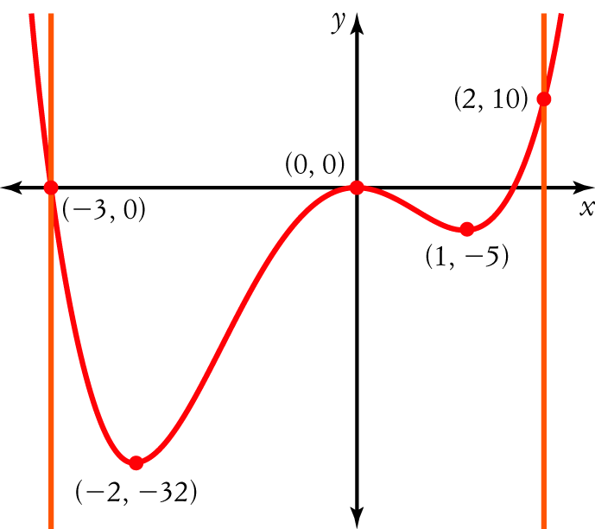
6 A local maximum for this function can be found at:
A (−2, −32)
B (−3, 0)
C (1, −5)
D (2, 10)
E (0, 0)

[1 mark]
7 The greatest value on the specified domain can be found at:
A (−2, −32)
B (−3, 0)
C (1, −5)
D (2, 10)
E (0, 0)

[1 mark]
8 The least value on the specified domain can be found at:
A (−2, −32)
B (−3, 0)
C (1, −5)
D (2, 10)
E (0, 0)

[1 mark]

Part B
10 short answer questions
50 marks
Show your working where appropriate.
1 If f (x) = 3x⁵ − 2x⁴ + x³ − 2, find:
a f (−1)

b f ʹ(−1)

[5 marks]
2 Sketch a primitive function for this graph.
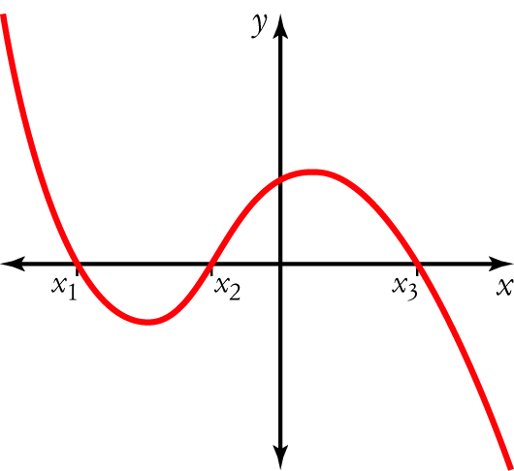

[5 marks]
3 The graph below shows the displacement of a particle.
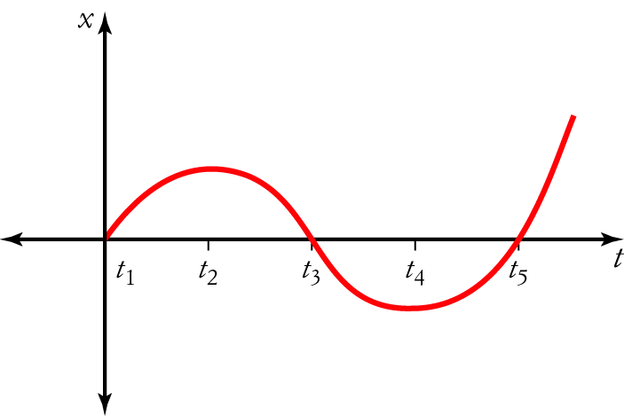
a When is the particle at the origin? _____________________________________________
b When is it at rest? _____________________________________________
c When is it travelling at its greatest speed? _____________________________________________

d Sketch the graph of its:
i velocity

ii acceleration.

[9 marks]
4 The height of a ball thrown in the air is given by the function h = 20t − 5t², where h is in metres and t is the time in seconds after the ball has been thrown.
a Find the ball’s height after 1 s.

b What is the maximum height of the ball?

c How long is the ball in the air for?

[6 marks]

5 A curve has 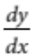= 6x² + 12x − 5. If the curve passes through the point (2, −3), find the equation of the curve.

[3 marks]
6 A curve passes through the point (0, −1) and the gradient at any point is given by (x + 3)(x − 5). Find the equation of the curve.

[4 marks]
7 The acceleration of a particle is given by 6t − 12 ms⁻². If the particle is initially at rest 2 m to the left of the origin, find its displacement after 5 seconds.

[5 marks]
8 Find all x values for which the curve y = 3x² − 18x + 4 is decreasing.

[3 marks]

9 Show that the function f (x) = 2(5x − 3)³ has a point of inflection at (0.6, 0).

[4 marks]
10 Find the greatest value of the curve y = x³ + 3x² − 24x − 1 in the domain −5 ≤ x ≤ 6.

[6 marks]
Part C
4 analysis questions
22 marks
Show your working where appropriate.
1 The rate of change of V with respect to t is given by 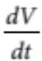= (2t − 1)². If V = 5 when t = , find V when t = 3.

[5 marks]
2 A particle moves so that its displacement after t seconds is x = 4t² − 5t³ metres. Find:
a its initial displacement, velocity and acceleration

b when the particle is at the origin

c its maximum displacement.

[7 marks]
3 Find the stationary points on the curve y = x³ + 6x² + 9x − 11 and determine their nature.

[5 marks]
4 The volume of air in a cubic room on a submarine is given by the formula
V = −4x³ + 27x² − 24x + 2, where x is the side length of the room in metres. Find the dimensions of the room that will give the maximum volume of air.

[5 marks]
Total marks: 80

Answers
Part A [1 mark each]
1 Volume (v) = antiderivative of R = 4t² + t³ + c
When t = 20, v = 10 970 = 4 × 20² + 20³ + c; so c = −5030
When t = 60, v = 4 × 60² + 60³ − 5030 = 225 370.
∴ C [1 mark]
2 Average rate of change = 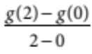 = 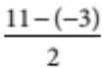 = 7
∴ E [1 mark]
3 For a minimum, the gradient (derivative) goes from negative to zero to positive.
∴ A [1 mark]
4 When t < −1, f ʹ(t) < 0, when t = −1, f ʹ(t) = 0 and when t > −1, f ʹ(t) < 0. Point of inflection at t = −1.
∴ B [1 mark]
5 Stationary points exist where f ʹ(x) = 0, i.e. x = 3 or x = −4.
When x < −4, f ʹ(x) < 0, when x = −4, f ʹ(x) = 0 and when x > −4, f ʹ(x) > 0. Minimum at −4.
When x < 3, f ʹ(x) > 0, when x = 0, f ʹ(x) = 0 and when x > 3, f ʹ(x) < 0. Maximum at 3.
∴ B [1 mark]
6 There is only 1 local maximum. It occurs at (0, 0).
∴ E [1 mark]
7 The greatest value of the function over the domain −3 ≤ x ≤ 2 is 10. It occurs at (2, 10).
∴ D [1 mark]
8 The least value of the function over the domain −3 ≤ x ≤ 2 is −32. It occurs at (−2, −32).
∴ A [1 mark]
Part B
1 a f (−1) = 3 × (−1)⁵ − 2 × (−1)⁴ + (−1)³ − 2 [1 mark]
= −8 [1 mark]
b f ʹ(x) = 15x⁴ − 8x³ + 3x² [1 mark]
f ʹ(−1) = 15 × (−1)⁴ − 8 × (−1)³ + 3 × (−1)² [1 mark]
= 26 [1 mark]
[5 marks]
2 Draw a set of axes and mark in points x₁, x₂ and x₃ in the same relative positions as they are on the graph of the function.
The primitive function will have stationary points at x₁, x₂ and x₃.
The primitive function will have:
• a positive slope from the left up to x₁ [1 mark]
• a negative slope between x₁ and x₂ [1 mark]
• a positive slope between x₂ and x₃ [1 mark]
• a negative slope from x₃ and beyond. [1 mark]
Draw the graph. [1 mark]
[5 marks]
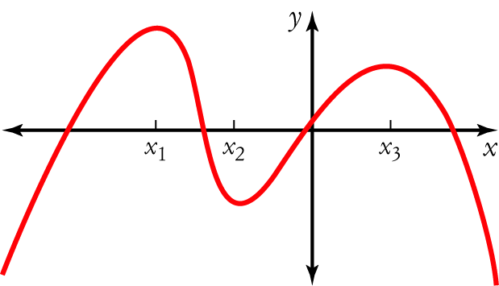
3 a The particle is at the origin when the graph crosses the t-axis. This occurs at t₁, t₃ and t₅. [1 mark]
b The particle is at rest when the velocity is 0. This occurs at the stationary points at t₂ and t₄. [1 mark]
c The greatest speed corresponds to the steepest slope of the graph. This occurs at t₅. [1 mark]
d Velocity is the derivative of displacement.
Draw up a set of axes and mark in the points at t₁ to t₅ on the t-axis. [1 mark]
The velocity graph will:
• have zeros at t₂ and t₄
• be positive from t₁ to t₂ and from t₄ to the right
• be negative between t₂ and t₄. [1 mark (for all features)]
Draw the graph showing these features. [1 mark]
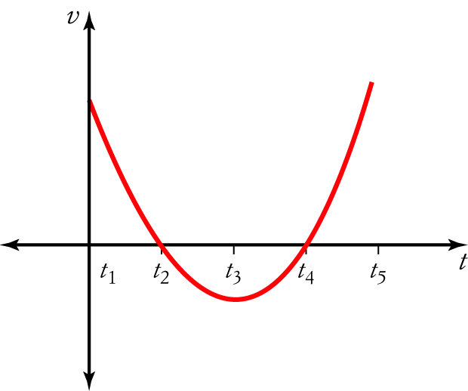
e Acceleration is the derivative of velocity.
Draw up a set of axes and mark in the points at t₁ to t₅ on the t-axis. [1 mark]
The acceleration graph will have:
• a zero at t₃
• be negative from t₁ to t₃
• be positive from t₃ to the right. [1 mark (for all features)]
Draw the graph showing these features. [1 mark]
[9 marks]
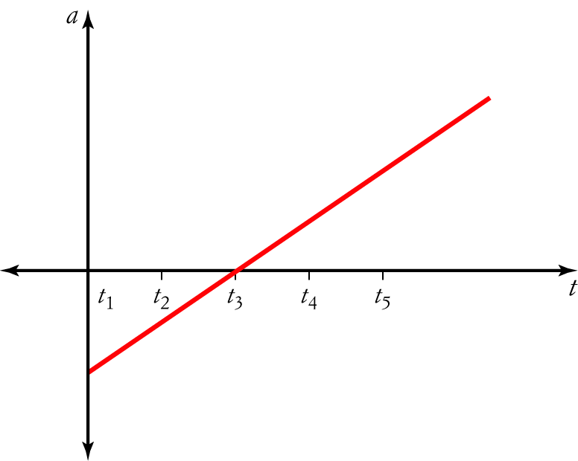
4 a h = 20 × 1 − 5 × 1² = 15 m [1 mark]
b Maximum height is reached when the velocity = 0
hʹ = v = 20 − 10t [1 mark]
Let v = 0; 20 − 10t = 0, so t = 2.
h = 20 × 2 − 5 × 2² = 20 m [1 mark]
c Ball is in the air while h > 0.
Let h = 0.
20t − 5t² = 0 [1 mark]
5t(4 − t) = 0
∴ t = 0 or 4 [1 mark]
The ball is on the ground at 0 s and 4 s.
The ball is in the air for 4 s. [1 mark]
[6 marks]
5 y = 2x³ + 6x² − 5x + c [1 mark]
When x = 2, y = −3
−3 = 2 × 2³ + 6 × 2² − 5 × 2 + c [1 mark]
∴ c = −33
y = 2x³ + 6x² − 5x − 33 [1 mark]
[3 marks]
6 = (x + 3)(x − 5) = x² − 2x − 15 [1 mark]
y = antiderivative of the gradient
= 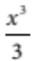 − x² − 15x + c [1 mark]

When x = 0, y = −1
−1 = 0 − 0 − 0 + c
∴ c = −1 [1 mark]
y = − x² − 15x − 1 [1 mark]
[4 marks]
7 Velocity is the antiderivative of acceleration.
v =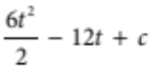 = 3t² − 12t + c [1 mark]
When t = 0, v = 0, so c = 0 and v = 3t² − 12t [1 mark]
Displacement is the antiderivative of velocity
s = 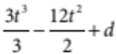 = t³ − 6t² + d [1 mark]
When t = 0, s = −2, so
−2 = 0 − 0 + d
∴ d = −2
and s = t³ − 6t² − 2 [1 mark]
When t = 5, s = 5³ − 6 × 5² − 2 = −27m [1 mark]
[5 marks]
8 yʹ = 6x − 18 [1 mark]
Let yʹ = 0.
6x − 18 = 0
∴ x = 3 [1 mark]
Stationary point at x = 3.
When x < 3, yʹ < 0, so y is decreasing when x < 3. [1 mark]
[3 marks]
9 f (x) = 250x³ − 450x² + 270x − 54 [1 mark]
f ʹ(x) = 750x² − 900x + 270x
= 30(5x − 3)² [1 mark]
Let f ʹ(x) = 0.
30(5x − 3)² = 0
∴ x = 0.6 [1 mark]
f ʹ(x) > 0 for all values of x except x = 0, and f ʹ(x) = 0 at x = 0.6, so there is a point of
inflection at x = 0.6. [1 mark]
[4 marks]
10 yʹ = 3x² + 6x − 24 = 3(x − 2)(x + 4) [1 mark]
Let yʹ = 0.
3(x − 2)(x + 4) = 0
∴ x = −4 or 2 [1 mark]
When x < −4, yʹ > 0; x = −4, yʹ = 0; x > −4 (but < 2), yʹ < 0. i.e. a local maximum. [1 mark]
When x = −4, y = 79, so there is a local maximum at (−4, 79).
When x < 2 (but > −4), yʹ < 0; x = 2, yʹ = 0; x > 2, yʹ > 0, i.e. a local minimum. [1 mark]
When x = 2, y = −29, so there is a local minimum at (2, −29).
When x = −5, y = (−5)³ + 3 × (−5) ² − 24 × (−5) − 1 = 69
When x = 6, y = 6³ + 3 × 6 ² − 24 × 6 − 1 = 179 [1 mark (for both boundary values)]
Draw a sketch.
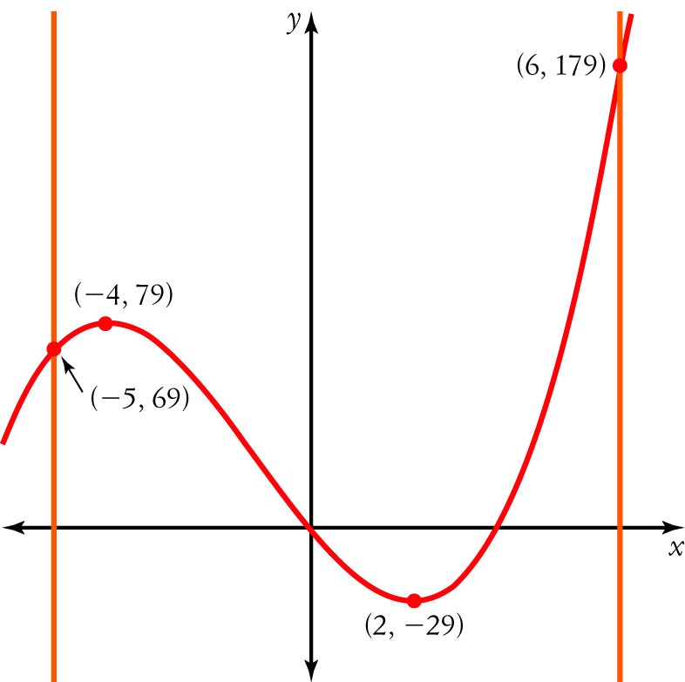
The global maximum value in the range −5 ≤ x ≤ 6 is 179. [1 mark]
[6 marks]
Part C
1 = 4t² − 4t + 1 [1 mark]
V = 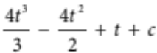 = 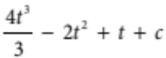 [1 mark]
When t = , V = 5.
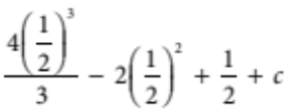 = 5 [1 mark]
⇒ c = 4
∴ V =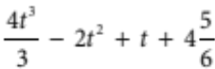 [1 mark]
Let t = 3.
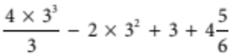 = 25
When t = 3, V = 25 [1 mark]
[5 marks]
2 a When t = 0, x = 4 × 0² − 5 × 0³ = 0 m [1 mark]
v = 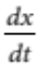= 8t − 15t²
When t = 0, v = 8 × 0 − 15 × 0² = 0 m/s [1 mark]
a = 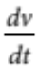 = 8 − 30t
When t = 0, a = 8 − 15 × 0 = 8 m/s² [1 mark]
b Let x = 0.
4t² − 5t³ = 0
t²(4 − 5t) = 0
∴ t = 0 s or 0.8 s [1 mark]
c Let = 0.
8t − 15t² = 0
t(8 − 15t) = 0
∴ t = 0 s or 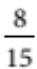s [1 mark]
When t < 0, < 0; when t = 0, = 0; and when t > 0 (but < ), > 0.
Minimum at 0.
When t < (but > 0), > 0, when t = , = 0 and when t > ,< 0.
Maximum at. [1 mark]
When t =, x = 4 ×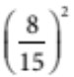 − 5 ×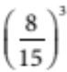 =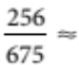 0.379 m
Draw a sketch.
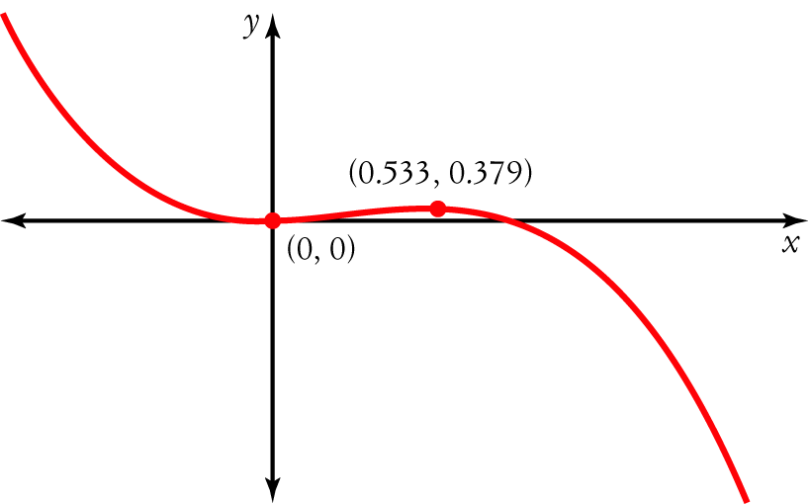
The maximum displacement is about 0.38 m. [1 mark]
[7 marks]
3 yʹ = 3x² + 12x + 9 [1 mark]
Let yʹ = 0.
3x² + 12x + 9 = 0
3(x + 1)(x + 3) = 0
∴ x = −1 or −3 [1 mark]
When x < −3, yʹ > 0; when x = −3, yʹ = 0; and when x > −3 (but < −1), yʹ < 0. Maximum at −3. [1 mark]
When x < −1 (but > −3), yʹ < 0; when x = −1, yʹ = 0; and when x > −1, yʹ > 0. Minimum at −1. [1 mark]
When x = −3, y = (−3)³ + 6 × (−3)² + 9 × (−3) − 11 = −11
When x = −1, y = (−1)³ + 6 × (−1)² + 9 × (−1) − 11 = −15
[1 mark]
The function has a local maximum at (−3, −11), and a local minimum at (−1, −15). [5 marks]
4 Vʹ = −12x² + 54x − 24 [1 mark]
Let Vʹ = 0.
−12x² + 54x − 24 = 0
−6(x − 4)(2x − 1) = 0
∴ x = 4 or [1 mark]
When x < , Vʹ < 0; when x = , Vʹ = 0; and when x > (but < 4), Vʹ > 0.
Minimum at . [1 mark]
When x < 4 (but > ), Vʹ > 0; when x = 4, Vʹ = 0; and when x > 4, Vʹ < 0.
Maximum at 4. [1 mark]
The room is cubic, so its dimensions are 4 m × 4 m × 4 m [1 mark]
[5 marks]
Topic test 1

